**ASSIGNMENT 2**

|  |  |
| --- | --- |
| Assignment Date | 19 September 2022 |
| Student Name | AJITH M |
| Student Roll Number | 715319106001 |
| Maximum Marks | 2 Marks |

**ABSTRACT**

Communication plays a significant role in making the world better place. Communication creates bonding and relations among the people, whether persona, social, or political views. Most people communicate efficiently without any issues, but many cannot due to disability. They cannot hear or speak,

which makes Earth a problematic place to live for them. Even simple basic tasks become difficult for them. Disability is an emotive human condition. It limits the individual to a certain level of performance. Being deaf and dumb pushes the subject to oblivion, highly introverted. In a world of inequality, this society needs empowerment. Harnessing technology to improve their welfare is necessary. In a tech era, no one should be limited due to his or her inability. The application

of technology should create a platform or a world of equality despite the natural state of humans.

**1. INTRODUCTION**

Communication should be universal without any barriers or limitations. This paper establishes a method for providing equality, turning the disabilities of the hearing and, or speech impaired individuals to abilities, creating a base where both the disabled and the able can communicate without any barrier. Our objective is to blend deaf and dumb within society and make them able to use their personal computers more effectively and efficiently. Our idea is to create sign assistance, like many applications which is using voice assistance such as Siri on iOS and Cortana on windows. There is need to develop an application that will create an interactive platform where the sign language can be translated to voice output and writing, and

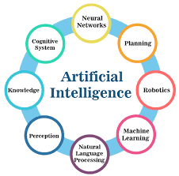

voice and writing input can also be converted to sign language. The bigger picture is creating an interactive model of communication for deaf and dumb

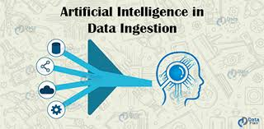

people. Developing an app will support this vulnerable society of impaired people and enhance communication among people

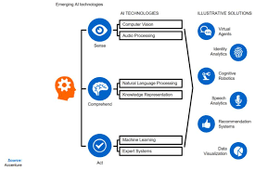

The project aims to develop a system that converts the sign language into a human hearing voice in the desired language to convey a message to normal people, as well as convert speech into understandable sign language for the deaf and dumb. We are making use of a convolution neural network to create a model that is trained on different hand gestures. An app is built which uses this model. This app enables deaf and dumb people to convey their information using signs which get converted to human-understandable language and speech is given as output.